# 12. Array of Objects Lab

**Tasks**

Download the starting files from Moodle for this lab.

In this zipped file you will find ALL the HTML and CSS code. I have also created the JavaScript file, but you will need to write the code for the functionality described below.

**Ensure that you have the console open** when you are testing your code. This way if an error occurs, the console will help/show you.

The following screen is created using HTML. When you click each button a corresponding JavaScript function will be called.

The JavaScript functions will access values in the form and dynamically update the page. You will create an **Array** of **Book Objects** in JavaScript to dynamically update the page too.

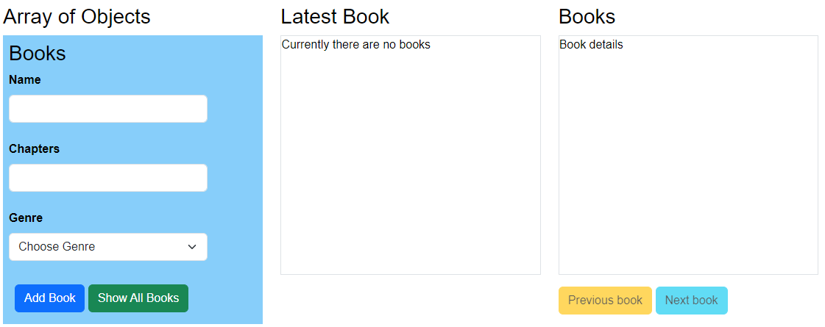

1. **Add Book.**

The user adds book details using the form below. Upon clicking the “Add” button, call a JS function to create a book object that contains the Name, Chapters, and Genre values from the form. Then add this book object to your **books** array.

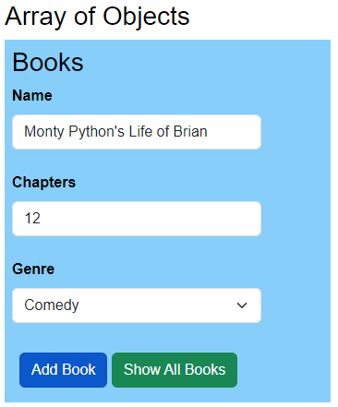

The user will receive an alert popup, informing them a book has been added. Then reset the form text box fields to blank (i.e., nothing).

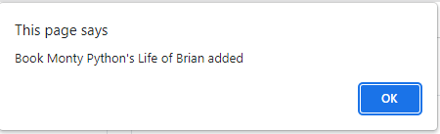

Look at the start code you downloaded, and you will see I have started the code for you.

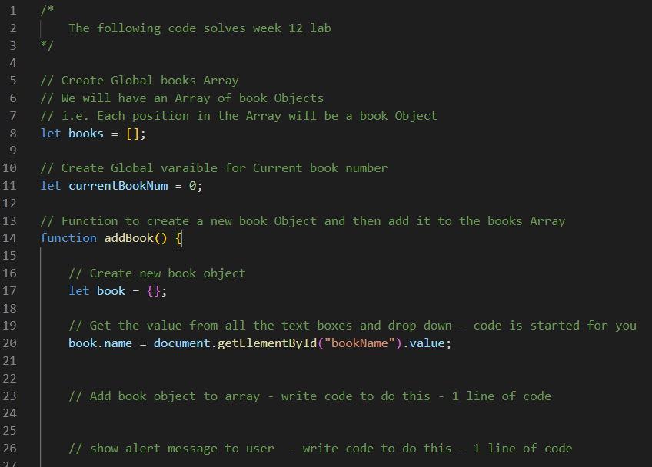

1. **Show All Books.**

Upon clicking this button, call a function to print all the book details to the console. To do this, you will need to iterate through the **array,** accessing each **object** to get the **name, chapters, and genre.**

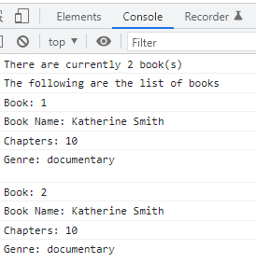

1. **Latest Book (second column)**

Every time a book is added (i.e., the user clicks the add book button), display the latest book details like below.

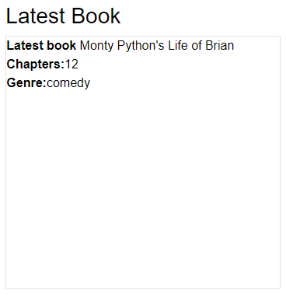

1. **Books (third column)**

When the user clicks the add book button for the first time, display the book details like below. You do not need to update this Books section (below) when the user clicks the add book button again.

Instead, the user clicks the previous and next buttons to show each book’s details here. To do this, you will need to iterate through your array of objects.

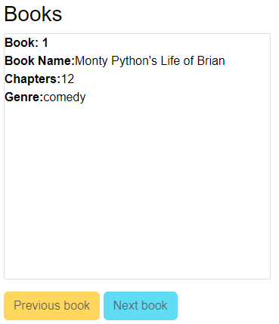

The user can then use the **next** button when more than one book is added. Of course, they cannot use the next button if they are looking at the last book.

The user can then use the previous button when they are viewing the second book or greater book number (i.e., book 3, book 4, etc.)

You will have to write the code to enable and disable these buttons accordingly.

For all the tasks above, you will need to write several JavaScript functions. This will take time and is not easy. Therefore, write a small bit of code at a time and test it. Print values to the console to help you debug and see the values of your variables.